# 1. LegacyBoolean

extend

impl

extend

extend

impl

**Abstract**

AbstractString

**Class**

LegacyBooleanImpl

**Abstract**

AbstractLegacyData

**Interface**

LegacyBoolean

**Interface**

DeclarationSupport

**Interface**

LegacyData

**Interface**

DataStructureSupport

extend

extend

# 2. LegacyInteger

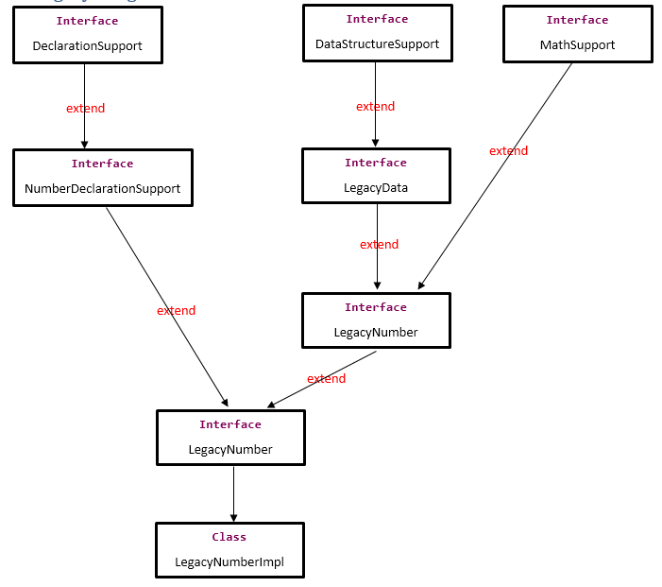

# 3. PackedDecimal - ZonedDecimal

**Interface**

MathSupport

**Interface**

DataStructureSupport

extend

Impl

extend

**Abstract**

AbstractDecimal

**Class**

PackedDecimalImpl

extend

**Abstract**

AbstractNumber

Impl

**Abstract**

AbstractLegacyData

extend

extend

**Interface**

PackedDecimal

extend

extend

**Interface**

LegacyNumber

extend

**Interface**

LegacyData

extend

**Interface**

NumberDeclarationSupport

**Interface**

DeclarationSupport